<Enter your photo or information here>

**ACADEMY OF**

**MODEL AERONAUTICS**

**WWW.MODELAIRCRAFT.ORG**



**ABOUT AMA CLUBS:** AMA clubs are the best resource for flying sites with improved runways,

safety and training programming, mentoring, and various social and community activities. Clubs

elect officers, conduct member meetings, acquire use of flying sites, sanction fun-fly and competition events, have cookouts, swap-meets/auctions, airshow demonstrations, and participate in advocacy and outreach initiatives within their community including aeronautical educational STEAM programs with local schools and youth organizations. AMA provides $5 million dollars of primary site owner coverage and 2.5 million dollars of coverage for members for chartered clubs to acquire flying sites.

**World’s Largest Aeromodelling**

**Membership Association**

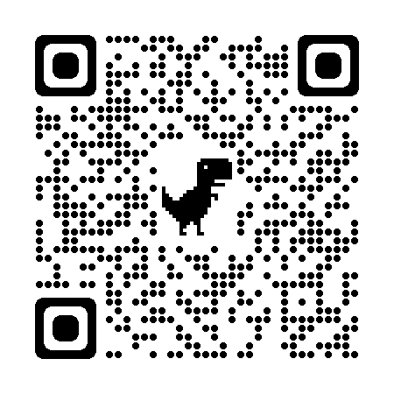

**ABOUT AMA:** The Academy of Model Aeronautics has a national membership of 170,000 members, 2,459 chartered clubs,

Your QR code here

**AMA District <**Enter your district or club information here> who fly model aircraft at permitted locations in accordance with AMA’s safety programming and FAA regulations.

2,800 flying sites, over 2,000 diverse sanctioned flying events each year. AMA is dedicated to the promotion of model aviation as a recognized sport, a recreational activity that is fun and challenging. The Academy provides STE(A)M based educational programming as a clear pipeline to STEM Industries such as aviation and engineering. **Use the QR codes in this handout or AMA websites to learn more.**

AMA was founded in 1936 and in the past 85 years has developed advanced Safety Programming and is now recognized by the FAA and the aviation community as the premiere aeromodelling CBO- Community Based Organization. AMA is a non-profit governed by a 13-member executivecouncil made up of the 11 elected AMA regional District Vice Presidents, an Executive Vice President, and a President. District VPs appoint district AVPs- Assoc. VPs to assist them to support members and clubs. Volunteer VPs, AVPs, club officers and members engage in public and educational outreach and representation in local communities, state, and national government advocacy activities.

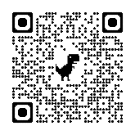

**WHY AEROMODELLERS JOIN THE AMA:** FAA UAS regulations require remote pilots to fly their model aircraft under the Safety Guidelines of an FAA recognized Community Based Organization (CBO) like the AMA: **🡨USE THE QR CODE TO** **JOIN THE AMA**.

* CRAFTSMANSHIP SATISFACTION
* CAMARADERIE WITH OTHER HOBBYISTS
* FLIGHT TRAININGPROGRAMS
* STEAM YOUTH EDUCATION
* SCHOLARSHIP PROGRAMS
* AMA SAFETY PROGRAMMING
* TURBINE JET WAIVERS & CERTIFICATION
* LARGE MODEL AIRCRAFT & PILOT CERTIFICATION
* NO REMOTE ID REQIRED AT FAA APROVED AMA FRIA SITES
* MODEL AIRCRAFT FLYING IS AWESOME
* LIABILITY INSURANCE UP TO $2.5 MILLION
* 2,450 AMA CLUBS IN USA
* ACCESS TO 2,800 SAFE FLYING SITES
* 110 AMA CLUBS IN NEW ENGLAND
* OVER 2,000 SANCTIONED EVENTS/YR.
* MEMBER, CLUB, & SITE INSURANCE

WHATEVER YOU FLY & WHEREVER

* FLY MORE TYPES OF MODEL AIRCRAFT
* NATIONAL/INTERNATIONAL COMPETITIONS
* FLY AT ALTITUDES WELL OVER 400 FT. AGL

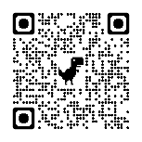

**AMA Remote Pilot Training:** An AMA club is your best opportunity for success in aeromodelling.

Nearly all clubs offer pilot flight training, and many offer the AMA Introductory Pilot Program

which provides 90 days of trial membership under the tutelage of an AMA Intro-Pilot Instructor.

Use the QR code to learn more about AMA’s flight school programs.

**FAA sUAS RECREATIONAL REGULATIONS REQUIREMENTS:**

1. The FAA Reauthorization Act of 2018 requires recreational Remote Operators/Pilots to comply with the following rules/law or be subject to fines or penalties:

2. Fly only for recreational purposes.

Follow the safety guidelines of an FAA-recognized Community Based Organization (CBO) like the AMA.

3. Keep model-aircraft within your visual line of sight or use a visual observer who is physically next to you.

4. Give way to and do not interfere with crewed aircraft.

5. Fly at or below 400' in controlled airspace Class B, C, D, and E near airports (Unless at AMA sites with Air Traffic Organization (ATO) Letters of Agreements to operate at higher altitudes).

6. Fly at or below 400 feet in Class G (uncontrolled) airspace (Unless at AMA sites that have had FAA risk assessments and mitigation allowing altitudes above

400 ft.)

7. Take the Recreational UAS Safety Test (TRUST) and carry proof of test passage.

8. Have a current registration certificate with you and registration number on the outside of model aircraft being flown.

9. Do not operate under influence of alcohol/drugs or fly model-aircraft in a careless/reckless manner.

QR Code if desired

Your photo or other info here

Enter your choice of photo/ other promotional info

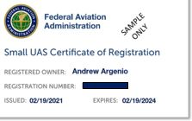

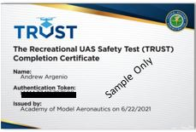

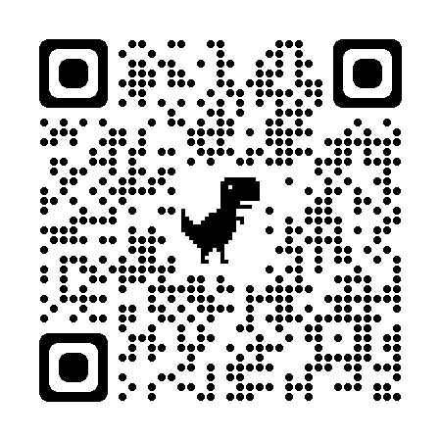

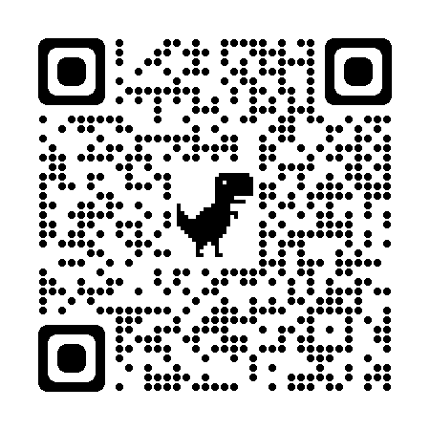

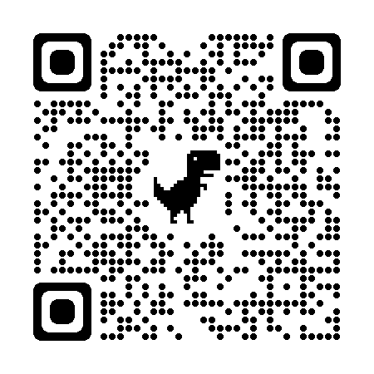

**FAA TRUST REQUIREMENT:** The Safety Test is less of a test and

more of a lesson on UAS/model aircraft safe flying. No studying is

required to pass. Read a few paragraphs in each section and

select answers to questions from multiple choices. Average time

20 minutes. Once completed, either print or retain an image of

the FAA Certificate to make available to the authorities if ever

requested. [www.modelaircraft.org/trust](http://www.modelaircraft.org/trust)

**$199.99**

**LISTING**

**OF LOCAL HOBBY**

**SHOPS**

**TWO POPULAR RECOMMENDED TRAINER AIRPLANES** at[www.horizonhobby.com](http://www.horizonhobby.com) **available online and/or at local dealers**. They are Ready to Fly (RTF) except for batteries and a charger. They feature SAFE technology with gyros that stabilizes the aircraft while learning to fly safely.

**Caption for your photo**

**Enter your contact info here**

Enter any additional info here

**$259.99**

**Apprentice**

**HBZ310001**

**AeroScout**

**HBZ38001**

**FAA REGISTRATION REQUIREMENT:** FAA regulations require

sUAS/model aircraft over 8 oz. to have a registration with the FAA. Recreational hobbyists are given a single registration number that must be marked on the outside of all the models they intend to fly. $5 fee/3 years covers the pilot. This one same number goes on all models. Pilots must retain an image/copy of their registration. [www.faadronezone.faa.gov](http://www.faadronezone.faa.gov)



Your QR to contact info

HORIZON HOBBY

